Mugo Book Club Kit Site Instructions

Contents
Landing Page 2
Options for Requesting a Book Club Kit 3
See All Items 4
Select a Specific Item 6
See Available Items for a Given Day 8
Booking Request Page 9

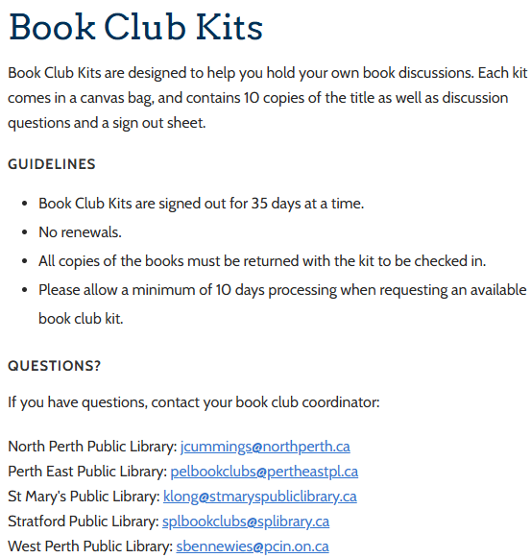
Landing Page

- Go to: www.mugolibrary.com/pcin/book-club-kits
  - The landing page will provide an overview of the guidelines and book club coordinator contacts for each PCIN library.
- Scroll down to the bottom of the landing page to see kits for booking.

Request a Book Club Kit
- There will be three options for booking a book club kit:
  - See all items
  - Select a Specific Item
  - See available items for a given day

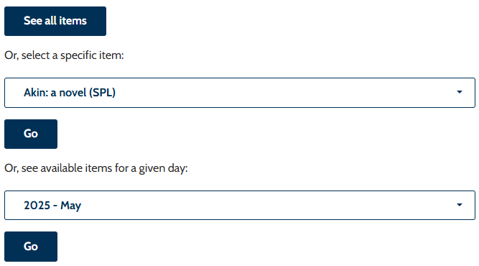

See All Items
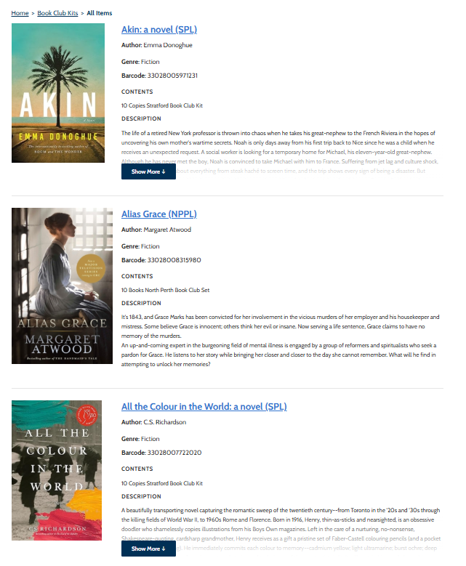
- Select the “See all items” button
- A new page will open with a list of all of the book club kits.
  - Select Show More to read the full description
- To see when the kit is available, click on the title of the book

- A new page will open – scroll down to see a calendar
  - Use the arrows on the calendar to find an available date to book
  - Click Reserve to be taken to the Book Request page
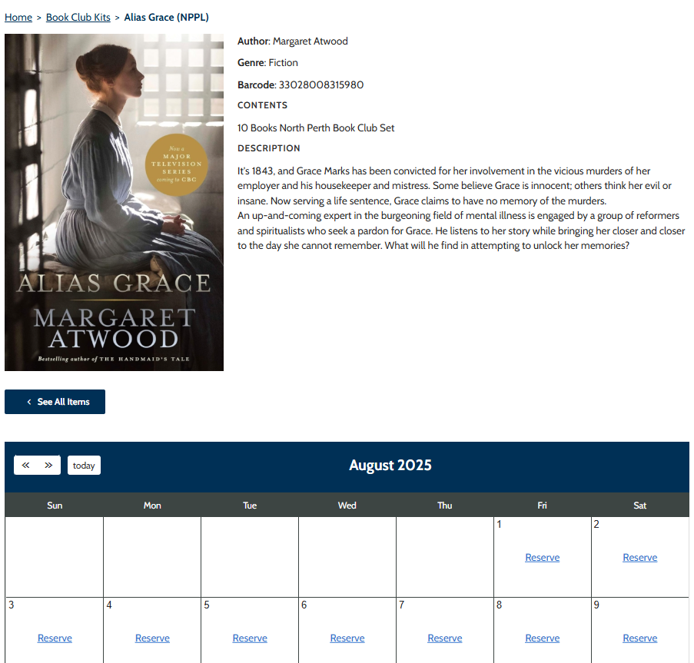

Select a Specific Item
- Use the dropdown menu to find an alphabetical list of book club kits
  - Click on the kit you’d like to check availability for and the dropdown menu will retract with your book choice
  - Select Go beneath the dropdown menu
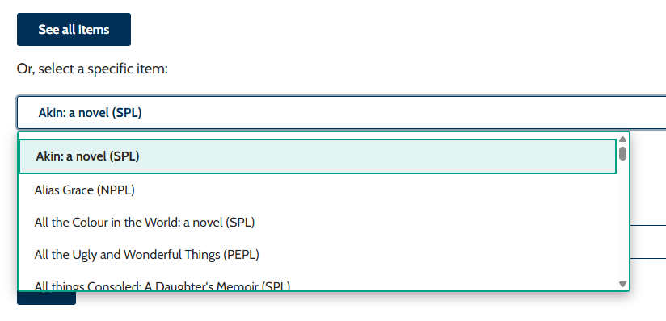

- A new page will open – scroll down to see a calendar
  - Use the arrows on the calendar to find an available date to book
  - Click Reserve to be taken to the Book Request page

See Available Items for a Given Day
- Use the dropdown menu to select the month you’d like to search for available book club kits
  - Click on the month you’d like to check availability for and the dropdown menu will retract with your month choice
  - Select Go beneath the dropdown menu
- A new page will open with a full month view of the selected month
  - Find the date and select “See Items” for a list of available kits to pop up.
  - Click on the title you wish to borrow and you’ll be taken to the Booking Request page.
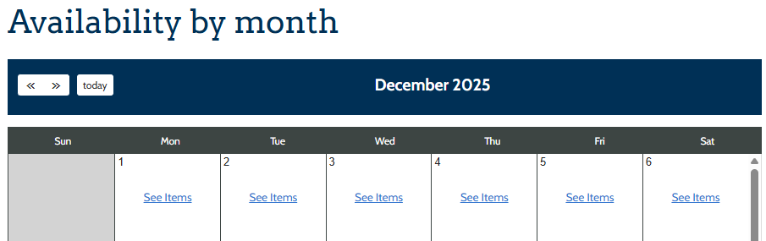
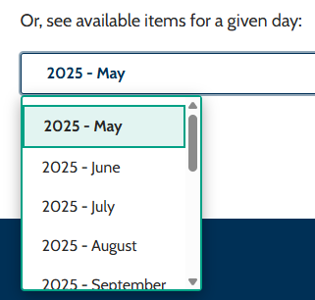

Booking Request Page
- To fill out a Booking Request, please include your Name, Email, where you’d like to pick up your item, Library Card and any notes that might be important for us to know (or your Book Club name). Phone numbers are optional, but preferred.
- Once you have filled out the requested fields, check off “I Agree” to the policy.
- Scroll down to the bottom of the page and select Reserve Item. You will receive a confirmation email with the pick up and due date. A reminder email is sent 24 hour in advance of your item being ready for pick up.
